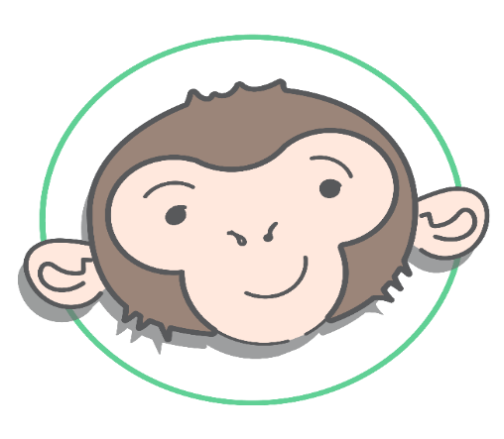Saturday 2nd September
Family fun session Booking Form
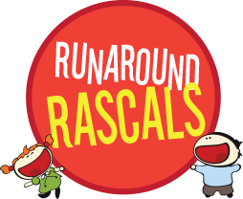
10.00am-2.00pm
Waddesdon Village Hall
Cha Char Chimps is hosting a summer day of fun, fun, fun! This is an extended version of your usual MUSIC experience, with other surprises too including SOFTPLAY and including delicious refreshments with homemade CAKE and drinks for both adults and children! Face painting and other bits and pieces too, also a BBQ and ICECREAM!

Please complete the form below and along with your payment, please use the envelope provided and return to Sue at CCC. Cash only please. Places are limited. Any questions please contact Sue on 07876701084 or sue@ccchimps.com
_ _ _ _ _ _ _ _ _ _ _ _ _ _ _ _ _ _ _ _ _ _ _ _ _ _ _ _ _ _ _ _ _ _ _ _ _ _ _ _ _ _ _ _ _ _ _ _ _ _ _ _ _ _ _ _ _ _ _ _ _
Booking Details
Your Name:-___________________________________________
Child or Baby name(s)____________________________________
______________________________________________________
Child age(s)____________________________________________
Email ___________________________________
Mobile/Tel No. _________________________________________
Party Location:-_________________________________________
Total payment enclosed £____________________
Dietary Requirements or allergies? _________________________
Drink requirements for adults (Tea, Coffee, decaf options, Diet Coke, Squash, Water)
Please select Quantity
Adults ______
Children ______
Extra Adults ______
Babies are very welcome, however due to soft play must be supervised at all times.
£3.50 per person, includes musical entertainment, softplay, yummy cakes and drinks.
Amount enclosed in envelope- in cash-
£ . p

